Chapter 20 Electromagnetism Review Problems

1) State the rules explaining how magnetic poles interact with each other

a) Draw a diagram of the magnetic field lines between 2 bar magnets placed:

i) North to North ii) South to North

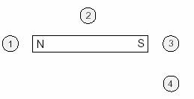

2)Describe and illustrate the direction of the magnetic field lines for a permanent magnet

1. A compass is positioned at each of the following locations near a bar magnet.

In which location will the compass needle point to the right-hand side of the page?

A. 1 B. 2 C. 3 D. 4

Draw the needle on the other 3 compasses shown above.

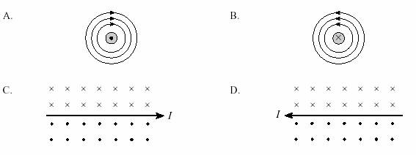3) Use the right-hand rule to determine the magnetic field direction for a current-carrying wire or a solenoid

a)Which of the following diagrams shows the magnetic field produced by a long current-carrying wire?

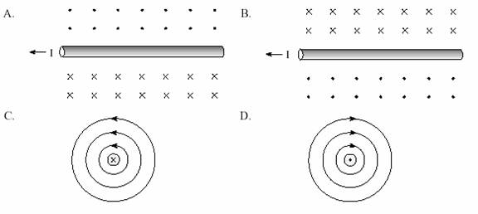b) Which of the following shows the magnetic field produced by a current carrying conductor?

Fix the incorrect pictures for both a and b by changing the arrows or direction of current.

4) Determine the direction of the force exerted on a current-carrying conductor or a moving charge that is within a magnetic field.

a) A current-carrying conductor is placed in a uniform magnetic field as shown to the right.

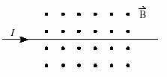

What is the direction of the magnetic force on this conductor?

A. Into the page B. Out of the page

C. Towards the top of the page D. Towards the bottom of the page

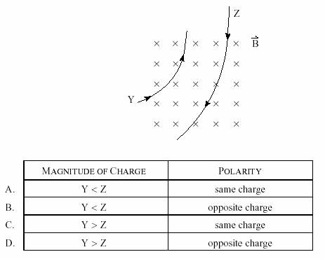b) Which of the following can not experience a magnetic force?

a. The north pole of a compass needle

b. A moving electron in a uniform magnetic field B

c. A stationary charge in a uniform magnetic field B

d. A current-carrying wire in a uniform magnetic field B.

c) Two particles Y and Z with equal mass and speed enter a uniform magnetic field and follow the paths as shown in the picture to the top right.

How do their magnitude and polarity of charge compare?

5) Solve problems that deal with a current-carrying conductor placed in a magnetic field and that involve, magnetic force, current, length of conductor in the field and magnetic field.

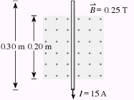a) Two parallel wires, each of length 1.0 m, are separated by 0.13 m and each carry 8.2 A of current. What is the force acting between the wires?

a. 0 N b. 1.26 x 10-5 N / m c. 1.0 x 10-4 N / m d. 6.5 x 10-4 N / m

A conductor is placed in a magnetic field as shown to the right.

b) What are the magnitude and direction of the magnetic force acting on this conductor when it carries a 15 A current?

MAGNITUDE OF MAGNETIC FORCE DIRECTION OF MAGNETIC FORCE

a. 0.75 N To the left

b. 0.75 N To the right

c. 1.1 N To the left

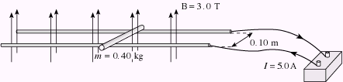d. 1.1 N To the right

c) A 0.40 kg metal slider is sitting on smooth conducting rails as shown to the right.

What is the magnitude and direction of the acceleration of the slider? (Ignore friction.)

a. 0.42 m/s2 left b. 0.42 m/s2 right c. 3.8 m/s2 left d. 3.8 m/s2 right

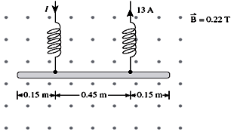

d) A 0.075 m metal rod is suspended as shown. A current of 13 A then flows as indicated.

(i) Does the tension in the springs increase or decrease? __________________ (1 mark)

(ii) By how much does the tension change? (3 marks)

e) Use principles of Physics to explain why two equally long current-carrying wires will exert attractive forces on each other if they each carry current in the same direction. (2 marks) **page 598**

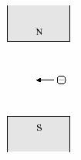

6) Describe the path of charged particles, moving perpendicular to magnetic fields (e.g., circles or arcs of circles

a)The diagram below shows an electron travelling to the left in a magnetic field.

In which direction will the electron be deflected?

A. into the page

B. out of the page

C. towards the north pole

D. towards the south pole

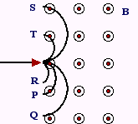b) When a certain proton enters a magnetic field **B** as shown below, it follows path P.

If an alpha particle, with twice the charge and four times the mass of a proton, enters the same magnetic field at the same speed, which path will it follow?

a. Path Q b. Path R c. Path S d. Path T

7) Solve problems that deal with a charge moving through a magnetic field and that involve magnetic force, charge, speed, magnetic field, centripetal force, mass, and radius

a)A doubly-ionized atom (*Q* = 2e) with a mass of 6.8 1027 kg enters a 3.0 T magnetic field with a speed of 5.0 107 m/s. What is the radius of the circular path of the atom?

A. 0.35 m B. 0.71 m C. 1.4 m D. 2.8 m

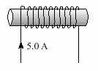b) A proton is accelerated from rest by a potential difference of 550 V. The proton is then subjected to a magnetic field of 0.42 T perpendicular to its direction of travel. This B field causes the particle to travel in a circular path of radius 1.23 x 10-2 m. What is the speed of the particle in the B field?

8) Solve problems that deal with a solenoid and that involve current, magnetic field (in the centre of the solenoid), number of turns per metre of solenoid

a) A 5.0 A current flows through a 0.20 m long solenoid that contains 1 500 loops.

What are the magnitude and direction of the magnetic field at the centre of the solenoid?

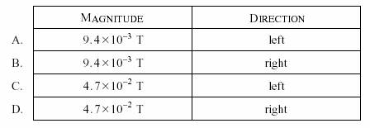

b) A 0.20 m long solenoid has 750 turns of copper wire and the magnetic field near its centre is measured to be 3.0 x 10-2 T. What is the current flowing through the solenoid?

a. 1.6 A b. 6.4 A c. 32 A d. 160 A

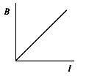c) The current through a solenoid is varied and the resulting magnetic field at its centre is recorded in each case. A graph of the B field versus current is produced

d) Which of the following best represents the slope of this graph?

a. μoN / L b. NL / μo c. μoB / L d. IL / N

e) A potential difference of 22 V is placed across a 570 turn solenoid that has a resistance of 4.9 Ω. The solenoid has a diameter of 0.052 m and is 0.37 m long. What is the magnetic field strength at the centre of this solenoid?

a. 0.0087 T b. 0.062 T c. 0.12 T d. 0.30 T

9) Apply the principles of electromagnetism to qualitatively explain the operation of a cathode-ray tube

a) An electromagnet is placed to the side of the electron gun. With the electromagnet turned off, electrons in a cathode ray tube strike the centre of the screen as shown.

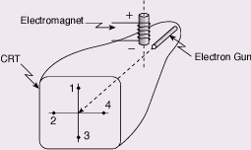

_________________________________________________________________________________________

_________________________________________________________________________________________

_________________________________________________________________________________________

_________________________________________________________________________________________

When the electromagnet is turned on, where will the beam now strike the screen?

a. 1 b. 2 c. 3 d. 4

Extra Problems

1. An ordinary wire carries 1.87 x 1020 electrons per second. What is the magnitude of the magnetic field at point 'P'?

a. 2.7 x 1042 T b. 1.4 x 103 T c. 2.9 x 10-4 T d. 3.9 x 1018 T

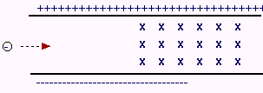

1. How fast must the electron shown below travel in order to pass undeflected through the crossed electric (2.1 x 103 N/C) and magnetic fields (4.2 x 10-3 T)

a. 2.0 x 106 m/s b. 2.0 x 106 m/s

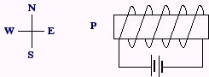c. 2.0 x 10-6 m/s d. 5.0 x 105 m/s

1. What is the direction of the magnetic field at point 'P'?

a. North b. South c. East d. West

1. It is possible to break a magnet into a **single** isolated north pole and a **single** isolated south pole.