Worksheet 2.1 -

A Worksheet
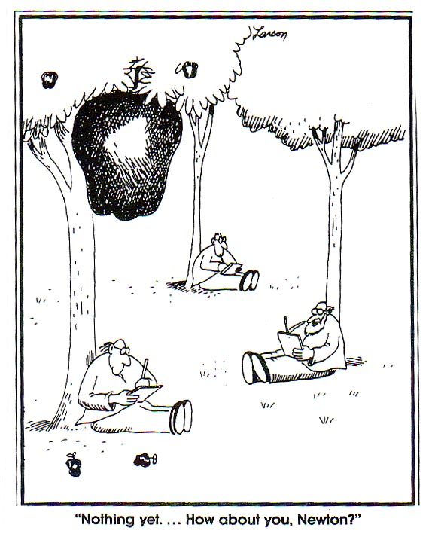
Show ALL WORK including knowns and steps taken to solve the problem!
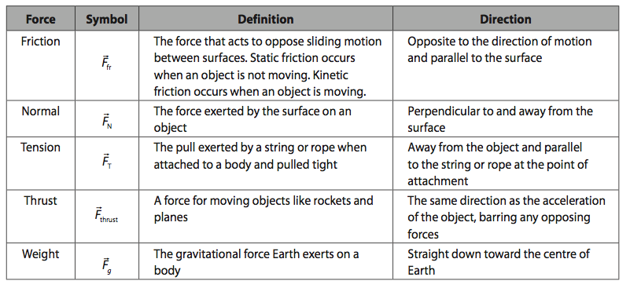

- How much force do the expanding gases in a gun barrel exert on a 6.0 g bullet as it accelerates from rest to 500.0 m/s in the 0.70 m long barrel?

- A 0.10 g spider is descending on a strand of web which supports it with a force of 5.6 x 10⁻⁴ N. What is the acceleration of the spider?

- A 75 kg criminal wants to escape from the 5th storey window of the jail, 24 m above the ground. He has a rope but it can only support a tension force of 650 N.
a. What is the minimum acceleration he can have as he lowers himself?
b. How fast is he traveling when he hits the ground below?

- If the force of friction between a 25 kg crate of expectations and the floor is 75 N, determine the force required to accelerate the crate at 1.5 m/s².

- A working boy pushes a 15 kg lawnmower at constant speed with a force of 90.0 N directed along the handle which is at an angle of 30° below the horizontal.
a) Calculate the friction force the boy is overcoming.
b) Calculate the normal reaction force on the mower from the ground.
BONUS) Calculate the coefficient of friction between the mower wheels and the ground.
BONUS 2) Calculate how hard the boy would have to push on the handle to give the mower an acceleration of 0.80 m/s².

- There you are standing on a train (off to Hogwart’s!) which begins to accelerate away from Platform 7 5/8 at 4.50 m/s². If you have a mass of 83 kg, what is the minimum force of friction required between your feet and the so that you do not slide backwards relative to the train?

- You are pushing a 3.75 kg textbook against a wall. What is the minimum force of friction between the book and the wall required so that it does not slip?

- A 1.20 x 10³ kg car is traveling at a speed of 22.5 m/s when the brakes are applied. If the car comes to a stop in 112 m, what is the braking force? (assume uniform deceleration)

- A hockey puck is shot along the ice at 11 m/s and slides 25 m before coming to a stop. What is the coefficient of friction?

- Two blocks (m₁ = 6.8 kg, m₂ = 5.2 kg) are in contact with each other while sitting on a frictionless surface as shown in the diagram. A horizontal force of 85 N is applied to m₁.
m₁
m₂

a. What is the acceleration of the system?
b. What is the force that m₁ exerts on m₂?

- A 42 N block is pulled along a horizontal surface by a force of 28 N as shown. What is the normal force on the block?
25º
42 N

- What is the tension in the cable of an 1.20 x 10³ kg elevator that is
a. accelerating downwards at 1.05 m/s²?
b. accelerating upwards at 1.05 m/s²?
c. moving down at a constant velocity?
1.0 kg
1.5 kg
- A 1.0kg box on a frictionless surface is attached to a 1.5 kg box as shown. What is the acceleration of the 1.0 kg box?

1.5
2.0

- Two masses are hung from a frictionless pulley as shown. What is the acceleration of:
a. the 1.5 kg block?
b. the 2.0 kg block?

- Two blocks are tied together as shown. IF a force of 20.0 N is applied to the 2.0 kg block:
3.0 kg
2.0 kg
T = 20.0 N

a. what is the acceleration of the blocks if the surface is frictionless?
b. What is the tension in the string joining the two blocks?
- Repeat question #15 when the coefficient of friction between the two blocks and the surface is 0.21.

Answers:
- (1.1 x 10³ N)
- (- 4.2 m/s² or 4.2 m/s² downward)
- a. (1.1 m/s²) b. (7.3 m/s)
- (110 N)
- a. (78 N) b. (1.9 x 10² N) BONUS (0.41) BONUS2 (1.1 x 10² N)
- (370 N)
- (37 N)
- (2.71 x 10³ N backwards)
- (0.25)
- a. (7.1 m/s²) b. (37 N)
- (30 N)
- a. (1.05 x 10⁴ N) b. (1.30 x 10⁴ N) c. (1.18 x 10⁴ N)
- (5.9 m/s²)
- a. (1.4 m/s² up) b. (1.4 m/s² down)
- a. (4.0 m/s²) b. (12 N)
- a. (1.9 m/s²) b. (12 N)

Forces in

Worksheet 2.2
- A dancer does the following Physics Jig move: 3 steps north, 2 steps west, 5 steps east, and 7 steps south. What is his:
  - resultant displacement?
  - total distance traveled?

- What is the magnitude of the resultant force of the three forces acting at point X? (Use compass coordinates)
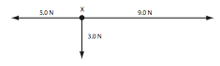
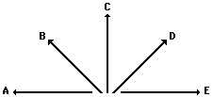
- Consider the following five force vectors.
Sketch the following and draw the resultant (R). Do not draw a scaled vector diagram; merely make a sketch. Label each vector. Clearly label the resultant (R).

i) B + D ii) E + B iii) A + C + D iv) B + E + D
78 N north

- A 2.4 kg soccer ball is kicked by two players simultaneously as shown.
a. Find the force on the ball.
b. Find the ball’s acceleration.
42 N east

- Two children pull a third child on a toboggan (shown from the top, assume up is north). Assuming that they pull on ropes that are parallel to the ground determine the magnitude of the force exerted on the toboggan.
66 N
130 N
33º
25º

- A pack of five Artic wolves are exerting five different forces upon the carcass of a 500-kg dead polar bear. A top view showing the magnitude and direction of each of the five individual forces is shown in the diagram at the right.
20 N 90º
30 N 45º
25 N 0º
50 N 270º
20 N 225º

What is the resultant force?

- A force of 100 N [N] and 200 [E] act on an object. Find the resultant (magnitude and direction).

- A force of 120. N [30.0 degrees N of E] and 80.0 N [40 degrees S of E] act on an object.

- Draw a vector diagram of the two original vectors
- Find the resultant of the two vectors. (Trig or Component method)
- What would a third force need to be to make the net force zero?

Worksheet 2.2 – Forces in 2D Answers

- a. 5 steps 37^{O} E of S b. 17 steps
- 5 N 37º S of E
- a. (89 N 28º E of N) b. (37 m/s² 28º E of N)
- (174 N, 354º)
- (39.4 N 35.6º S of E)
- (224 N 63º E of N)
- a. b. (165 N 3º N of E) c. (165 N 3º S of W)

Worksheet 2.3 - Complete on a separate piece of paper! Draw a free body diagram for EACH of the following. Include all the known values and show ALL work (including a lead equation that demonstrates understanding)
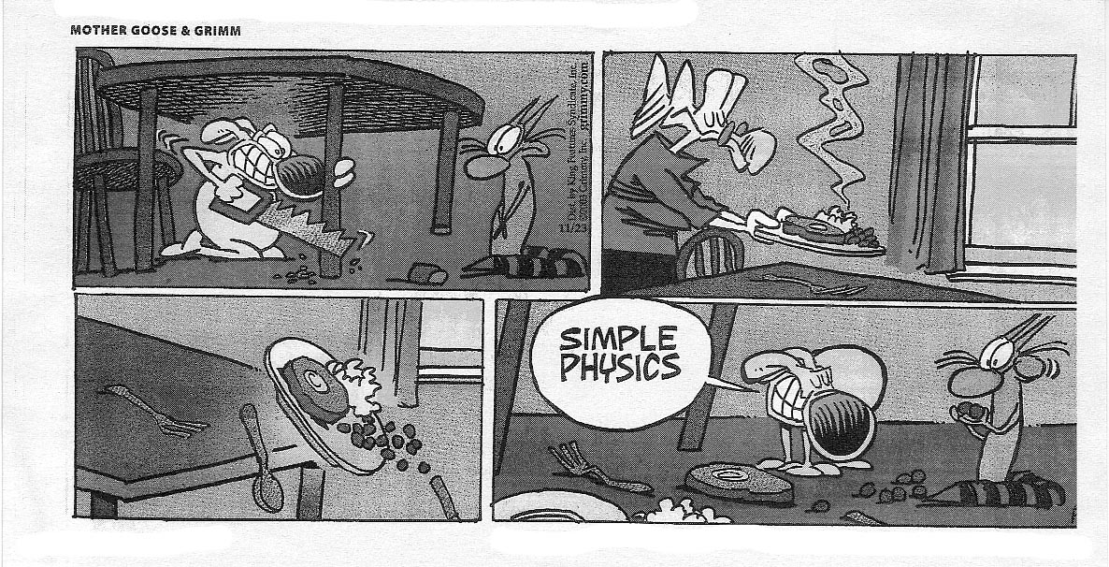
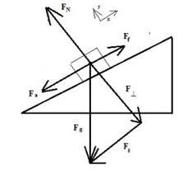

- A criminal wants to escape from the third story window of a jail by going down a rope to the road below. Having taken high school physics, he thinks he can escape down the rope even though his mass is 75 kg and the rope can only support 65 kg without breaking. Explain how he can get down safety without breaking the rope.

- A 7.6 kg object is at rest on an inclined plane. If the plane makes an angle with the horizontal of 33º what is the normal force acting on the object?

- A 7.6 kg object is pulled up an inclined plane. If the plane makes an angle with the horizontal of 33º and the coefficient of friction is 0.20, what is the force of friction?

- A 16.2 kg object slides down an inclined plane at a constant velocity. If the plane makes an angle of 25º, what is the normal force acting on the object?

- A 445 N box is sliding down a frictionless 25º inclined plane. Find the parallel component of the weight that causes the box to slide

- A 325 N box is sliding down a frictionless 30.0º inclined plane. What is its acceleration?

- A 435 N box is sliding down a 40.0º inclined plane. If the acceleration of the box is 0.250 m/s², what is the force of friction acting on the box?

- A student pulls a 125 N object up a 25º incline. If the coefficient of friction is 0.180, what force must the student pull with to move the object at a constant velocity? Assume the applied force is parallel to the ramp (why would that matter?)

Unit Connection! Acceleration is the gatekeeper between the Kinematics and Dynamics Units.

Try the next two NON-Incline problem first:

- A 110 kg motorbike carrying 50.0 kg rider coasts to a stop in a distance of 51 m. It was originally traveling 15 m/s. What was the stopping force exerted by the road on the motorbike and rider? (HINT: start with kinematics)
- A truck of mass 2.00 x 10³ kg is towing a large mass boulder of mass 5.00 x 10² kg using a chain (of negligible mass). The tension in the chain is 3.00 x 10³ N. And the force of friction of the boulder is 1.20 x 10³ N.
  - At what rate will the boulder accelerate? (Hint: Start with Drynamics!)
  - How far will the boulder move in 3.0 s, starting from rest?

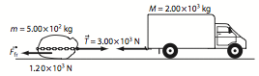

- Fluffy the cat slides freely down the long porcelain cat slide into the Beverly Hills pet pool. If the incline is 18° and μ = 0.10 determine the time it takes Fluffy to reach the bottom of the 10. m slide.
(HINT: find acceleration first, don’t worry about the cat’s mass, it cancels out)

- A trucker loses his brakes and hits the bottom of a runoff road (put there to protect against such a situation) at 150 km/h. The runoff road is inclined at 50° and friction against the truck is approximately equal to a sliding coefficient of 0.20. If the runoff road is 100 m long, is it long enough?

Worksheet 2.3 - Answers:

- If he presses his feet against the wall at an angle of 30º, he lowers the tension on the rope to a point where he safety lower himself an escape! Criminals are so badass (well not really…)
- (62 N)
- (12 N)
- (144 N)
- (188N)
- (4.90 m/s²)
- (269 N)
- (73.2 N)
- (-3.5 x 10² N)
- a. (3.60 m/s²) b. (16 m)
- (3.1 s)
- (just barely, by 1.0 m)

