Name: ________________________ Electromagnetism 1 Block: ______

Review of Science 10

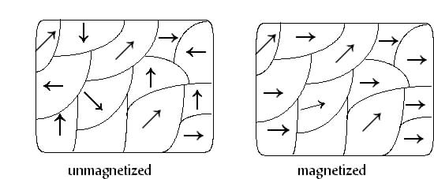In Science 10 we learned that certain objects called **magnets** can exert a **force** on **iron** and other **ferromagnetic**

**materials** such as cobalt, nickel, and gadolinium. **Magnets** are made of **________________** **materials**, usually iron, and have **special properties at the** **atomic level**, which allow them to be **magnetized**. Small groups of atoms in a **ferromagnetic material** are called **domains** and each **domain** has its own **magnetic field**. As shown in the pictures to the right.

The **domains** of a material can be **aligned,** made to point the same direction, by an **external magnetic field** and in doing so produce what is called a **permanent magnet**. A **magnetized ferromagnetic** material can be demagnetized by making the **magnetic domains** point in different directions. This can be accomplished by changing _________ of the magnet or by hammering it.

A **magnet** has two ends which are called _________. The two poles are called North and South, and the **magnetic field** that is produced is directed **from the** **North to the South**. The **magnetic field** interacts with other magnetic fields in a similar way that the electric field interacts with other electric fields. The similar interaction can be summarized as: Opposite poles attract and like poles repel.

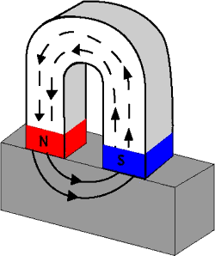

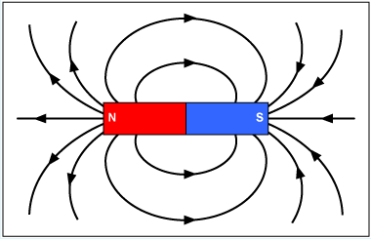The two pictures illustrate how **magnetic field lines** are shown for a bar magnet (left) and a horseshoe magnet (right).

Notice that the field inside the magnet is from S to N, but outside it points from N to S.  
Practice: Draw the magnetic field lines for the combinations of bar magnets and label the unlabelled poles.

N S

S N

N S

N S

S N

N S

S N

S Me = 5.98 x 1024 kg re = 6.38 x 106 m G = 6.67 x 10-11 Nm2/kg2

c)

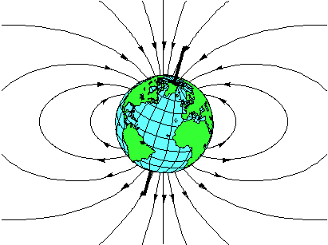If a bar magnet is suspended by something and allowed to rotate, it will rotate so that its **North pole** points in the direction of the magnetic field surrounding it. This simple device is called a **compass** and was being used by the Chinese as early as the 11th century for sea navigation.

The Earth is like a big bar magnet and if no other magnet fields are around a **compass** will **point in the direction** of **magnetic field from** the Earth. We say that the **North pole** of the **compass needle** points to the **magnetic north pole,** but it is actually a South pole since opposite poles attract.

**Magnetic North** is not the same as **geographic North**, which is the top location on the dark line representing Earth’s axis of rotation.

Electromagnetism

It was observed in the 18th century that an **electric current can deflect a compass needle** the same way a **magnetic field can**, and a connection between these two phenomenon was 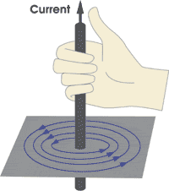sought.

It was found that a current carrying wire creates a magnetic field around it in a circular shape with the wire at the center. The direction of the magnetic field can be found with the **first right hand rule**.

To use the first right hand rule you:

1. Point your right thumb in the direction of **conventional current**.
2. Curl your fingers around the wire, and they point in the direction of the magnetic field.

Sometimes a wire is shown to be going into or out of the page, or a magnetic field is directed in or out of the page.



For a magnetic field going into the page, the symbol used is an x and for the field going into the page it is a dot.

If a current carrying wire is wrapped into a circular shape or loop, it is then called a **solenoid**. By placing an iron core in the **solenoid** you can create an **electromagnet**. The magnetic field for solenoid is similar to that of a bar magnet as shown.



To determine the direction of the magnetic field inside and around a solenoid you can use the first or second right hand rule.

2nd RIGHT-HAND RULE

If you grasp the coil with the right hand and curl your fingers around the loops in the direction of the conventional current, your thumb points towards the North pole of the electromagnet.

